ACOUNTDTLS

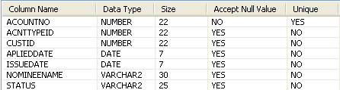
ACOUNT_TYPE_MSTR
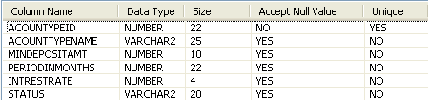
BILLDETAILS
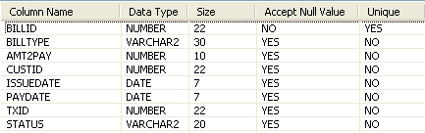
CARDAPPLINGDTLS
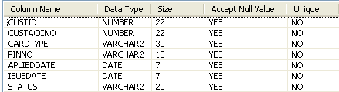

CUSTLOANDTLS
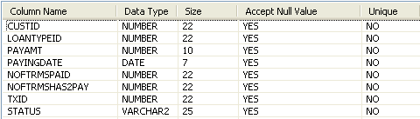
CUSTOMER
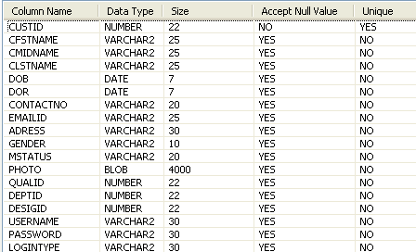
DEPTMSTR
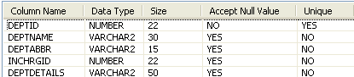
DESIGMSTR
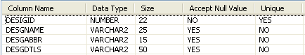

EMPLOYEESMASTER
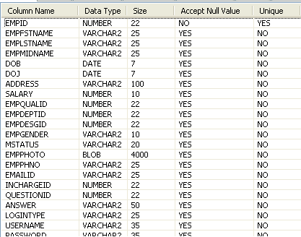
LOANMASTER
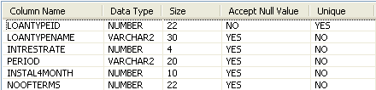
QUALMSTR
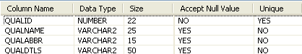
QUERIESANDSOLV
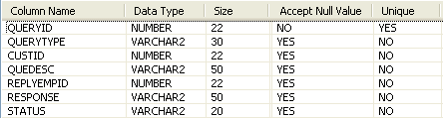

QUESTIONMASTER
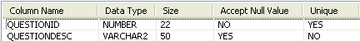
TRANSFERAMT
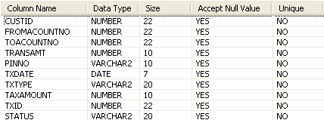
USERAUTHDETAILS
